בס"ד

**Virtual Router – Modeling**

<https://virtualrouter.codeplex.com/>

By: Tamar Bash

Maor Taieb

**What is Virtual Router?**

Virtual Router is a free, open source software based router for PCs running Windows 8, Windows 7 or Windows Server 2008 R2.

Using Virtual Router, users can wirelessly share any internet connection (Wifi, LAN, Cable Modem, Dial-up, Cellular, etc.) with any Wi-Fi device (Laptop, Smart Phone, iPod Touch, iPhone, Android Phone, Zune, Netbook, wireless printer, etc.)

These devices connect to Virtual Router just like any other access point, and the connection is completely secured using WPA2 (the most secure wireless encryption.)

**How it works ?**

The Wireless Network create/shared with Virtual Router uses WPA2 Encryption, and there is no way to turn off that encryption. This is actually a feature of the Wireless Hosted Network API's built into Windows 7 and 2008 R2 to ensure the best security possible.

You can give your "virtual" wireless network any name you want, and also set the password to anything.

**Modeling**

In order to understand the modeling part we have asked some questions:

1. What classes do we have?
2. What is the responsibility part of every class?
3. Which class is the “manager”?
4. What are the relations between the classes?

We will answer the questions one by one.

1. Our modeling is in high level, therefore it refers to the project solutions and not to real classes. **The project includes the following solutions:**

ICS

WLAN

Client

Host

Host Console

Installer

Service

1. **Classes responsibility**

Virtual router ICS - The ICS solution deal with the connection status. Also managing the device connections

Virtual router WLAN - The WLAN solution is basically includes all network issue and protocols such as Mac Address, connection mode, security etc.

Virtual router client - Since the solution works as Server Client platform we need usually to install client side. Here we use the default way of client side to create connection. The Client solution deal with the connection to the server.

Virtual router Host - This is the solution that turns the host Wi-Fi card to work as router. Also take care of sharing issues, such as witch nic will do the Routing.

Virtual router Host Console - This is the GUI part.

Virtual router Installer - This solution contains the msi and dll files that go onto registry.

Virtual router service - This solution gives the ability to work at background service.

1. **The “manager” class is client**

(This means that when the program starts running, the first instance is client type).

We can see it in the client main program that only creates a single instance manager and make it run.

1. **Relations between the classes**

UML Diagram

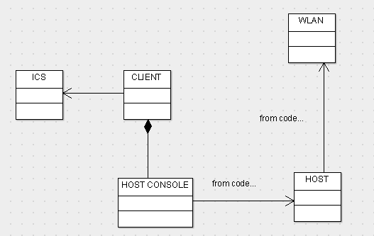

Relations explanation:

Client and Host Console have an aggregation relation, because when the application is turned on, they both are created at the same time.

Host Console and Host have an association relation, because the Host Console solution uses the Host solution functions.

Host and Wlan have an association relation, because the Host solution uses the Wlan solution to create the router.

Client and ICS have an association relation, because the Client solution uses the ICS solution to create new connections.

Sequence Diagram for connection scenario

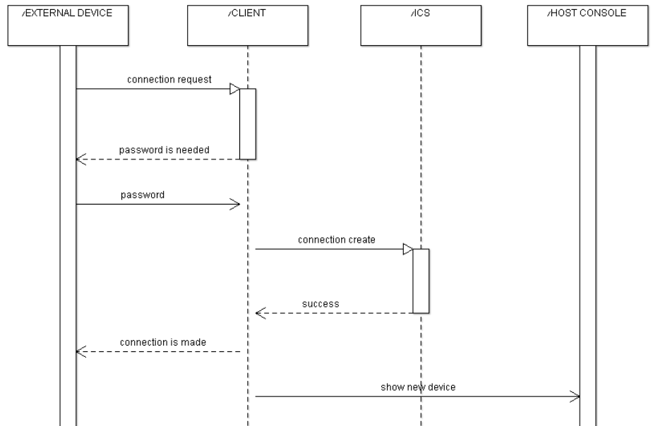

Sequence explanation:

When an external device is trying to connect the VR, the CLIENT manager asks for password.

When the correct password is entered, CLIENT manager uses the ICS class to create the connection.

Then the user can see that the connection was made and GUI class present the new device.

**Conclusion**

The Virtual Router project roughly includes the management part and the networking part. The code does not have documentations, and we haven’t found any explanation about its modeling. However, it is easy to see that the project is modular. Every solution has its own responsibility, so we can easily change a part of it with no need to update the whole system. It is very important, especially because it is an open source project, so people usually expect that adding their own features will be simple. More than that, you can add features to your virtual router even if you have no idea in computer networking, just do not touch the WLAN solution.

The modularity also helped us to understand the relations between the solutions (which is represented in the class diagram).

In summary, although we would be happy to find some documentation, it seems that the project modeling is well planned, to be easy to use and easy to understand.